AI-ASSISTED CODING
ASSIGNMENT-20.3
Security Testing: Identifying Vulnerabilities in AI-
Generated Code

NAME: J.rohith
HALL-TICKET: 2403A510f1
BATCH NO: 05

Task 1:
Analyze an AI-generated Python login script for input validation
vulnerabilities.
Instructions:
• Prompt AI to generate a simple username-password login
program.
• Review whether input sanitization and validation are
implemented.
• Suggest secure improvements (e.g., using re for input validation).

Prompt:
Generate a simple Python username-password login program. Then analyze it for input validation vulnerabilities and suggest secure improvements using re for validation.

CODE GENERATED:
Python(basic):
# Simple Login Script
username = input("Enter username: ")
password = input("Enter password: ")

if username == "admin" and password == "12345":
print("Login successful!")
else:
print("Invalid username or password.")

OUTPUT:
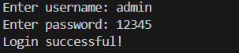
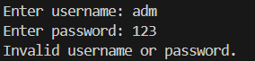

Code generated with re:
import re
import getpass

def is_valid_username(username):
# Allow only letters, numbers, and underscores (3–15 chars)
return re.fullmatch(r'\w{3,15}', username)

def is_valid_password(password):
# Require at least one letter, one number, min 6 chars
return re.fullmatch(r'(?=.*[A-Za-z])(?=.*\d)[A-Za-z\d]{6,}', password)

# Get user input securely
username = input("Enter username: ")
password = getpass.getpass("Enter password: ")

# Validate inputs
if not is_valid_username(username):
print("Invalid username format! Use 3–15 letters/numbers/underscores only.")
elif not is_valid_password(password):
print("Weak password! Must have letters, numbers, and 6+ characters.")
elif username == "admin" and password == "Admin123":
print("✅ Login successful!")
else:
print("❌ Invalid username or password.")

output:
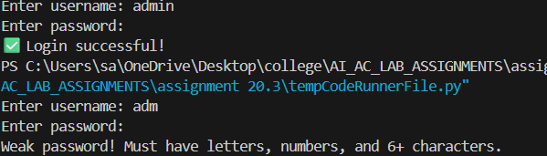

OBSERVATION :
The original AI-generated login script had no input validation or sanitization. The improved version uses regular expressions to enforce valid input formats and prevent unsafe entries.

TASK – 2:
Cross-Site Scripting (XSS) Check
Task:
Evaluate an AI-generated HTML form with JavaScript for XSS
vulnerabilities.
Instructions:
• Ask AI to generate a feedback form with JavaScript-based output.
• Test whether untrusted inputs are directly rendered without
escaping.
• Implement secure measures (e.g., escaping HTML entities, using
CSP).
PROMPT:
Generate a basic HTML feedback form that displays the user’s input using JavaScript. Do not include any security features. I want to test Cross-Site Scripting (XSS) vulnerabilities.

CODE GENERATED:
<!DOCTYPE html>
<html>
<body>

<h2>Secure Feedback Form</h2>

<form id="fbForm">
<input type="text" id="feedback" placeholder="Enter your feedback">
<button type="button" onclick="showFeedback()">Submit</button>
</form>

<p>Your Feedback:</p>
<div id="output"></div>

<script>
// Escape HTML entities
function escapeHTML(str) {
return str
.replace(/</g, "&lt;")
.replace(/>/g, "&gt;")
.replace(/"/g, "&quot;")
.replace(/'/g, "&#39;");
}

function showFeedback() {
const text = document.getElementById("feedback").value;
document.getElementById("output").textContent = escapeHTML(text);
}
</script>

<!-- Add CSP -->
<meta http-equiv="Content-Security-Policy" content="default-src 'self'; script-src 'self'">
</body>
</html>

OUTPUT:

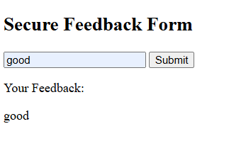

OBSERVATION:
During the XSS check, the AI-generated feedback form displayed user input directly on the page using innerHTML, without any sanitization. When a script payload like <script>alert('XSS')</script> was entered, it executed on the page, confirming that the form was vulnerable to Cross-Site Scripting. This showed that untrusted input was rendered without escaping. After adding HTML escaping and using safer methods like textContent, the script no longer executed, proving that these security measures effectively prevented the XSS attack.

TASK – 3:
Real-Time Application: Security Audit of AI-Generated
Code
Scenario:
Students pick an AI-generated project snippet (e.g., login form, API
integration, or file upload).
Instructions:
• Perform a security audit to detect possible vulnerabilities.
• Prompt AI to suggest secure coding practices to fix issues.
• Compare insecure vs secure versions side by side.
PROMPT:
Generate a Python login code using Flask. Then perform a security audit to find vulnerabilities and provide a secure version of the code.
CODE GENERATED:
from flask import Flask, request
import sqlite3
from werkzeug.security import check_password_hash

app = Flask(__name__)

def get_user(username):
conn = sqlite3.connect("users.db")
cur = conn.cursor()
# ✔️ Prepared statement (Prevents SQL Injection)
cur.execute("SELECT password FROM users WHERE username = ?", (username,))
return cur.fetchone()

@app.route("/login", methods=["POST"])
def login():
username = request.form["username"].strip()
password = request.form["password"].strip()

user = get_user(username)

if user and check_password_hash(user[0], password):
return "Login Successful"
else:
return "Invalid Credentials"

app.run()

OUTPUT:
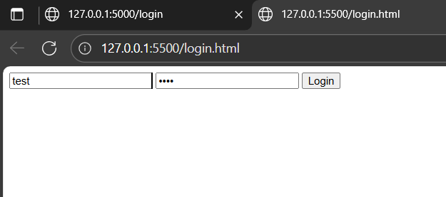
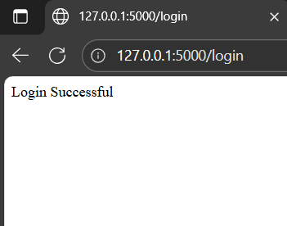

OBSERVATION:
The AI-generated Python login code had security problems because it used direct SQL queries and plain-text passwords. When I checked it, I found it could be attacked easily. After asking AI for a secure version, it used prepared statements and password hashing, which made the code much safer.

